REDOX ASSIGNMENT TEST - 2013

/25
Name: _______________________________________
Part 1: Electrochemical cells
The following passage is relevant to all questions in Part 1.

The fundamental electrochemical cell concepts can be applied to any cell. All electrochemical cells will have an anode and a cathode. The reactants at these electrodes will be separated within the cell so that electrons cannot be exchanged directly: they must travel through the external circuit. There will also be a substance within the cell that provides mobile ions that maintain electrical neutrality throughout the cell.

The nickel–hydrogen cell is a relatively new type of battery that was developed for the US space program. They are currently used in the International Space Station (ISS) for energy storage. The ISS circles the Earth every 90 minutes. While it is in sunlight, solar cells may be used to generate electricity. The nickel–hydrogen cells store some of this electrical energy and release it again when the ISS is in darkness.

Each cell consists of a nickel–nickel oxyhydroxide (NiOOH) cathode, and a platinum anode at which hydrogen gas is oxidised. The electrolyte is concentrated potassium hydroxide, about 30% m/m. The cell is a pressure vessel, since it must hold a significant quantity of hydrogen gas. It is thus very expensive but long-lived, with a lifespan of up to 20 years. Each cell consists of many ‘stacks’. One such stack is shown below.

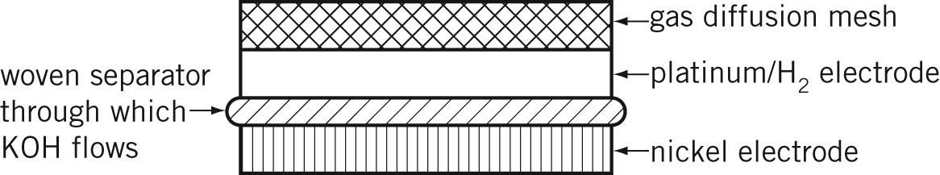

The major electrode reactions during the discharge process are listed:
Cathode: NiOOH(s) + H₂O(l) + e–→ Ni(OH)₂(s) + OH–(aq)
Anode: H₂(g) + 2OH–(aq) → 2H₂O(l) + 2e–

No. |  | Question | Answer
 |  | Why is it necessary to have energy-storage cells such as the nickel–hydrogen battery aboard the International Space Station? | The International Space Station gets energy from the Sun when it can, but sometimes it is in darkness, so cells are needed to store energy that can be used during the ‘dark’ times.  (1)
2 |  | What is the oxidation number of nickel in:  a NiOOH  b Ni(OH)₂ | a +3  b +2
3 |  | During the recharging process, what is the  a reducing agent?  b oxidising agent? | a. Ni(OH)₂  b. H₂O
4 |  | Write a balanced redox equation for the discharge process. | 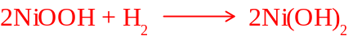  (1)
5 |  | How would the concentration of the electrolyte change during the recharging process? | Circle one of the choices below  INCREASE DECREASE UNCHANGED (1)  K⁺ not consumed or produced  OH⁻ produced and consumed at same rate
6 |  | How would the pressure inside the cell change during:  a recharging?  b discharging? | Circle one of the choices in parts (a) and (b)  a. INCREASE DECREASE UNCHANGED (1)  b. INCREASE DECREASE UNCHANGED (1)
7 |  | What would be three requirements of the material used for the separator? | 1.(1) Able to conduct KOH  2.(1) impermeable to H₂, H₂O etc  3.(1) Is inert?
8 |  | What would happen if the separator were left out of the stack? | The cell would not work as electrons would not have to pass through the external part of the circuit.  (1)
9 |  | State one advantage and one disadvantage of this cell. | Advantage: long life (1)  Disadvantage: expensive (1)

Part 2: Corrosion

A farm fence is made of wooden posts with five strands of galvanized (zinc coated) wire between the posts. One of the
posts has a steel sign nailed to it.

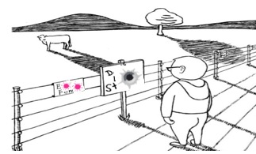

A) After a particularly wet winter the sign fell off because the iron nails had rusted. Explain why the iron nails had more rust on the part that had been inside the post. Include relevant equations and a diagram. (3)

Rusting is more extensive in areas where [O₂] is lowest – differential aeration.

Anode: Fe(s) → Fe²⁺(aq) + 2è

Cathode: O₂(g) + 2H₂O(l) + 2è→ 4OH⁻(aq)

B) The farmer repaired the fence and replaced the steel sign using copper nails thinking that they would not corrode in the post. However, the sign fell off again a few months later. Explain why. (2)

An electrochemical cell is created when two different metals (Cu and Fe) are in direct contact where

Anode: Fe(s) → Fe²⁺(aq) + 2è (most extensive at the area around copper nail)

Cathode: O₂(g) + 2H₂O(l) + 2è→ 4OH⁻(aq) (at the copper nail)

Over time, the hole around the nail became larger due to the corrosion issue mentioned above and the sign fell off due to looseness

C) The next summer the fence was burned in a bush fire. Explain why the wire strands rusted very quickly after the
fire. Hint: the melting point of iron is approximately 1535 ºC and the melting point of zinc is about 520 ºC. (2)

The bush fire caused the plated zinc outer layer to melt and left the Fe wire exposed to the weather i.e. corrosion occurred.

Note: It is also possible that not all of the zinc plating was removed from the bush fire and therefore an electrochemical cell could have been set up between the zinc and the iron thereby preventing corrosion.

D) After the fire, the farmer replaced the fence posts with expensive top-of-the-range aluminium tubes and used steel (iron) wiring between the posts. Is this a wise choice? Explain. (3)

Yes

When iron is connected to aluminium, the aluminium (being more reactive) is oxidised instead of the iron.

However, this will cause the post to degrade over time, is this preferable to the wire rusting?

Anode: Al(s) → Al³⁺(aq) + 3è

Cathode: O₂(g) + 2H₂O(l) + 2è→ 4OH⁻(aq)



